**Complaints**

We welcome comments, suggestions and complaints so that we can continually improve our service to you. Please contact the Practice Manager in person or by phone, letter or email if you have a comment, suggestion or complaint.

We take complaints very seriously and have an effective procedure to resolve any problems in the shortest possible time. You can read more about our procedure in our complaints policy. We always want to have satisfied patients.

**The Information Commissioner**

The Information Commissioner is an independent public body and reports directly to Parliament. Further information is available at: www.ico.gov.uk

**Responding to Freedom of Information requests**

All requests for information will be responded to within 20 working days. A fee can be charged when dealing with a request. This will be calculated in accordance with the Act. If a fee is required for information requested, the 20 day timescale can be extended to up to three months.

Should the request for information exceed the charges set by the Secretary of State, this practice does not have to action the request.

**Lawful bases**

The lawful basis for processing your personal data are outlined in our Privacy Notice, [which is published on our website at [www.sandy.dental](http://www.sandy.dental) Please ask reception if you would like a copy.

**Policies and procedures**

The practice has a number of important policies that detail how we provide care and service to our patients. Please ask the Practice Manager if you would like to see copies of the following policies or procedures which have further detail on how we process personal data:

* Confidentiality Policy
* Information Governance Procedures
* Complaints Handling Policy
* Privacy Notice
* Data Protection and Information Security Policy

You can view our Privacy Notice on our website at

[www.sandy.dental](http://www.sandy.dental)

Or telephone or visit to ask reception for a paper copy.

**Our dentists/doctors**

Mr U H Patel BDS and Associates

Full list of dentists on our website www.sandy.dental

**Sandy Dentalcare**

10 Market Square

Sandy, Beds., SG19 1HU

www.sandy.dental

Email: sandydentalcare@sandydentalcare.co.uk

Fax: Not used

Practice Owner: Uday Patel, Principal Dentist

Business Manager: Karen Webb

Patient Manager: Monika Cross

**Your personal information**

**How we look after and safeguard information about you**

**Sandy Dentalcare**



Patient Leaflet (M 217P), Version 6

Information for patients

\\\\\\\\\\\\\\\Proetecting your information

### How your records are used

**Sharing information**

The information held about you will not be shared for any reason, unless:

* You ask us to do so
* We ask and you give us specific permission
* We are required by law, for example prescribers must be notified where a patient presents a repeat prescription and the pharmacist becomes aware of clinically significant issues arising in connection with that prescription
* We are permitted by law, for example where public interest overrides the need to keep the information confidential

Anyone who receives information from us also has a legal duty to keep this information confidential, subject to recognised exceptions of the types

listed above

**Your right to view your clinical records**

You have the right to view the original of your clinical records. Generally, we will not charge for this service. To request a copy, please write to the Patient Manager. The practice will respond as soon as possible, within 1 month. For more complex requests, the practice may take up to 3 months, but will inform you within 1 month if and why more time is required.

**Confidentiality**

You have the right to confidentiality. We also comply with the NHS Code of Practice on Confidentiality and healthcare personnel have a requirement under their professional code of ethics to keep records about you confidential, secure and accurate.

All of our staff contracts of employment contain a requirement to keep patient information confidential.

.

**Protecting your information**

Our Information Governance Lead is Mr Uday Patel. We aim to provide you with the highest quality of dental care. To do this we need to keep records about you, your health and the care we have provided or plan to provide to you. We know that you value your privacy and the security of personal information held about you.

**Information recorded**

Information recorded about you may include:

* Basic details, such as address, date of birth, next of kin
* Details and clinical records about your treatment, medical and social health
* Records of medicines you have been prescribed
* Information relevant to your continued care from other people who care for you and know you well, such as other health professionals and relatives

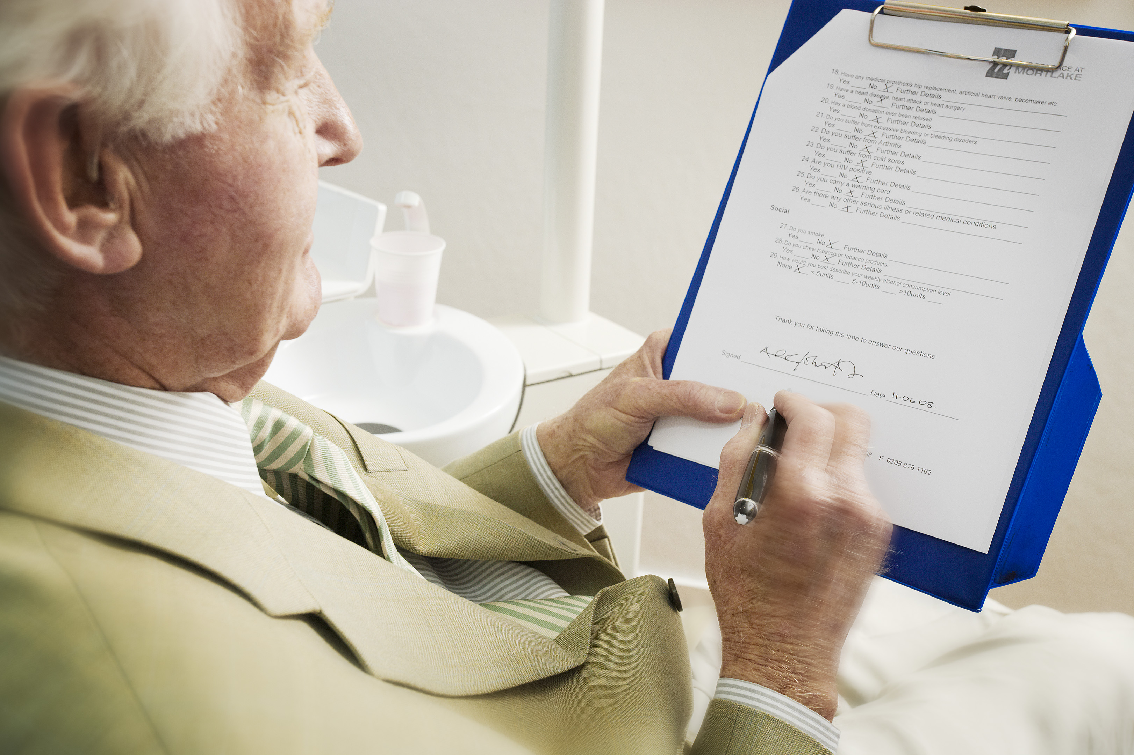

**Our guiding principle is that we hold your records in**

**strict confidence.**

**Freedom of Information (FOI) Act 2000**

The Freedom of Information Act, gives the general right of access to all types of recorded information held by the practice. The intention of the Act is to encourage a spirit of openness and transparency in the NHS and the whole public sector. Our organisation aims to fully support this.

Any individual or organisation can make a request for information. The applicant does not have to explain why this information is requested.

**Our Publication Scheme**

This practice has developed a publication scheme. It is a guide to information, routinely published and gives indication of information intended to be published. The publication scheme describes the form in which the information is published and any fees that will be charged. A request can be made from information listed in this publication scheme.

If you would like a copy of our publication scheme please contact the Information Governance Lead.

